A business needs to prepare a trading and profit and loss account first before moving on to the balance sheet. Trading and profit and loss accounts are useful in identifying the gross profit and net profits that a business earns.

The motive of preparing trading and profit and loss account is to determine the revenue earned or the losses incurred during the accounting period.

The trading and profit and loss account are two different accounts that are formed within the general ledger. The two parts of the account are:

1. Trading Account

2. Profit and Loss Account

Trading account is the first part of this account, and it is used to determine the gross profit that is earned by the business while the profit and loss account is the second part of the account which is used to determine the net profit of the business.

**1. Trading Account**

Trading account is used to determine the gross profit or gross loss of a business which results from trading activities. Trading activities are mostly related to the buying and selling activities involved in a business. Trading account is useful for businesses that are dealing in the trading business. This account helps them to easily determine the overall gross profit or gross loss of the business. The amount thus determined is an indicator of the efficiency of the business in buying and selling.

The formulae for calculating gross profit is as follows:

**Gross profit = Net sales – Cost of goods sold**

Where

**Net sales = Gross sales of the business minus sales returns, discounts and allowances.**

The trading account considers only the direct expenses and direct revenues while calculating gross profit. This account is mainly prepared to understand the profit earned by the business on the purchase of goods.

Items that are seen in the debit side includes purchases, opening stock and direct expenses while credit side includes closing stock and sales.

Closing entries for Gross Loss or Gross Profit , the following entries are passed

**In case of Gross Loss**

Profit and Loss A/c      Dr.

To Trading A/c

**In case of Gross Profit**

Trading A/c     Dr.

To Profit and Loss A/c

**Preparing Trading Account**

Trading account is prepared by closing all the temporary purchases and revenue accounts and making adjustments in the inventory accounts by the use of a closing journal entry

For the following question, prepare a trading account

|  |  |  |  |
| --- | --- | --- | --- |
| **Particulars** | **Amount** | **Particulars** | **Amount** |
| Sales | 2,05,000 |  |  |
| Sales returns | 15,000 |  |  |
| Purchases | 49,000 |  |  |
| Purchases returns | 3000 |  |  |
| Opening inventory | 8000 |  |  |
| Closing inventory | 30,000 |  |  |
| Trading Account | 1,500 |  |  |

The format of trading account after passing the closing entry is as follows:

|  |  |  |  |  |
| --- | --- | --- | --- | --- |
| **Dr.                                     Trading Account for the year ended                                                          Cr.** | | | | |
| Sales returns | 15,000 |  | Sales | 205,000 |
| Purchases | 49,000 |  | Purchase returns | 3,000 |
| Beginning inventory | 8,000 |  | Ending inventory | 9,000 |
| Balance c/d | 145,000 |  |  |  |
| **Total** | **217,000** |  | **Total** | **217,000** |
|  |  |  | Balance b/d | 145,000 |
|  | | | | |

In this example, all accounts are closed and transferred to the trading account. The credit entry of 1,45,000 is the gross profit for the period.

**2. Profit and Loss Account**

Profit and loss account shows the net profit and net loss of the business for the accounting period. This account is prepared in order to determine the net profit or net loss that occurs during an accounting period for a business concern.

Profit and loss account get initiated by entering the gross loss on the debit side or gross profit on the credit side. This value is obtained from the balance which is carried down from the Trading account.

A business will incur many other expenses in addition to the direct expenses. These expenses are deducted from the profit or are added to gross loss and the resulting value thus obtained will be net profit or net loss.

The examples of expenses that can be included in a Profit and Loss Account are:

1. Sales Tax

2. Maintenance

3. Depreciation

4. Administrative Expense

5. Selling and Distribution Expense

6. Provisions

7. Freight and carriage on sales

8. Wages and Salaries

These appear in the debit side of Profit and Loss Account while Commission received, Discount received, profit obtained on sale of assets appear on the credit side.

Net profit can be determined by deducting business expenses from the gross profit and adding other incomes obtained

Net profit = Gross profit – Expenses + Other income

Closing Entries for Net Loss or Net Profit:

i. In case of Net Loss

Capital A/c – Dr.

To Profit and Loss A/c

ii. In case of Net Profit

Profit and Loss A/c -Dr.

To Capital A/c

**Trading and Profit and Loss Account Format**

Trading and Profit and Loss Account format is represented separately as follows:

Format for Trading Account

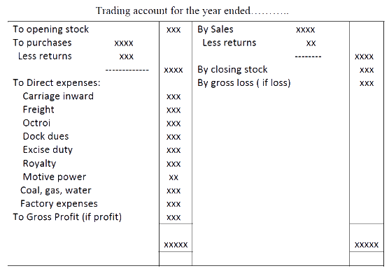

Format for Profit and Loss Account

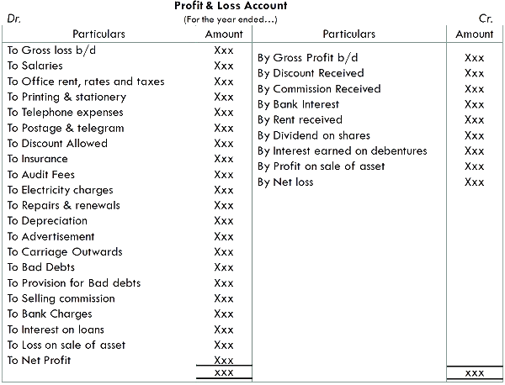

**Difference between Trading and Profit and Loss Account**

The following points of difference exist between the Trading and Profit and Loss Account

|  |  |  |
| --- | --- | --- |
| **Parameters** | **Trading Account** | **Profit and Loss Account** |
| **Meaning** | Trading account used to find the gross profit/loss of the business for an accounting period | Profit and loss account or Income statement is used to find the net profit/loss of the business for an accounting period |
| **Timing** | Trading Account is prepared first and then profit and loss account is prepared. | Profit/Loss Account is prepared after the trading account is prepared. |
| **Purpose** | For knowing the gross profit or gross loss of a business | For knowing the net profit or net loss of a business |
| **Stage** | It is the first stage in the creation of the final account. | it is the second stage in the creation of the final account. |
| **Dependency** | It is not dependent on trial balance | It is dependent on trading account |
| **Transfer of Balance** | The balance in the form of Gross loss or Gross Profit of the trading account will be transferred to the Profit and Loss Account | The balance in the form of Net loss or Net Profit of the profit and loss account will be transferred to the Balance Sheet |
|  |

## What is a Balance Sheet?

The Balance Sheet is a statement that shows the financial position of the business. It records the assets and liabilities of the business at the end of the accounting period after the preparation of trading and profit and loss accounts

**‘**Not-for-Profit’ Organisations design Balance Sheet for determining the financial position of the establishment. The preparation of the balance sheet is on the same pattern as of the trade entities. It depicts liabilities and assets as during the end of the year. Assets are depicted on the right-hand side, whereas the liabilities are depicted on the left-hand side.

However, there will be a General Fund or Capital Fund in place of the Capital and the surfeit or deficit as per Income and Expenditure A/c which is either deducted from or added to the capital fund, as the scenario may be. It is a common practice to add some of the subsidised items like entrance fees, legacies and life membership fees precisely in the capital fund.

## What is the purpose of balance sheet?

The main purpose of the balance sheet is to show a company’s financial status. This sheet shows a company’s assets and liabilities, along with the money invested in the business. This statement is required to analyze the financial status information for several consecutive periods.  
Generally, investors and creditors look at the balance sheet of the company to understand how effectively a company will use its resources and how much it can give in return. Though the balance sheet can be prepared at any time, it is mostly prepared at the end of the accounting period. The balance sheet can be created at any time. However, it is often prepared at the end of the financial year.

**How to Prepare a Balance Sheet?**

Below are the steps mentioned to prepare a balance sheet.

1. **Compose a trial balance-** It is a regular report included in any accounting programme. If it is a manual mode, then create a trial balance by transferring every general ledger account’s ending balance to a spreadsheet.
2. **Arrange the trial balance-** It is important to arrange the initial trial balance to assure that the balance sheet similar to the relevant accounting structure. While using adjusting entries to adjust the trial balance all the entry should be completely recorded so the auditors can understand why it was made.
3. **Discard all expense and revenue accounts-** The trial balance includes expenses,  revenue, losses, gains, liabilities, equity, and assets. Delete all from the trial balance except equity, liabilities, and assets. However, the deleted accounts are used to create an income statement.
4. **Calculate the remaining accounts-** In this stage, sum up all the trial balance account used to create a balance sheet. The typical line items used in the balance sheet are:
   * Cash
   * Accounts receivable
   * Inventory
   * Fixed assets
   * Other assets
   * Accounts payable
   * Accrued liabilities
   * Debt
   * Other liabilities
   * Common stock
   * Retained earnings
5. **Validate the balance sheet-** The total for all assets recorded in the balance sheet should be similar to the liabilities and stockholders’ equity accounts.
6. Present in the required balance sheet format.

**Balance Sheet Format:**

The balance sheet of a company will look like the image given below.

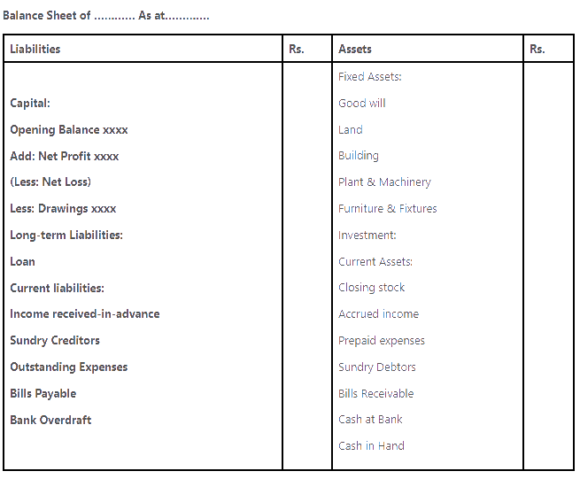

|  |
| --- |
|  |

The Alfa manufacturing Company Limited was registered with a nominal capital of Rs 6, 00,000 in Equity Shares of Rs 10 each.

**The following is the list of balances extracted from its books on 31st December, 2004:**

[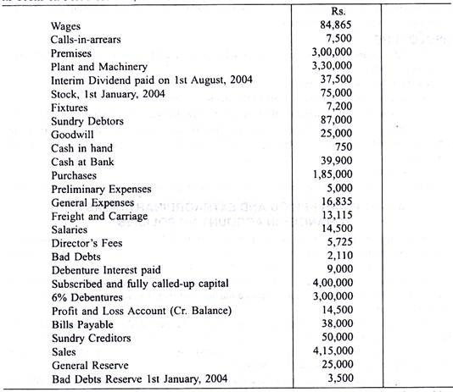](https://cdn.accountingnotes.net/wp-content/uploads/2017/01/clip_image065_thumb2_thumb-1.jpg)

**Prepare Trading and Profit and Loss Account and Balance Sheet in proper form after making the following adjustments:**

Depreciate Plant and Machinery by 10%. Write off Rs 500 from Preliminary Expenses. Provide half year’s Debenture interest due. Leave Bad and Doubtful Debts Reserve at 5% on Sundry Debtors. Stock on 31st December, 2004, was Rs. 95,000.

[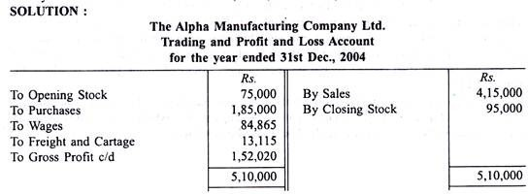](https://cdn.accountingnotes.net/wp-content/uploads/2017/01/clip_image067_thumb2_thumb.jpg)

[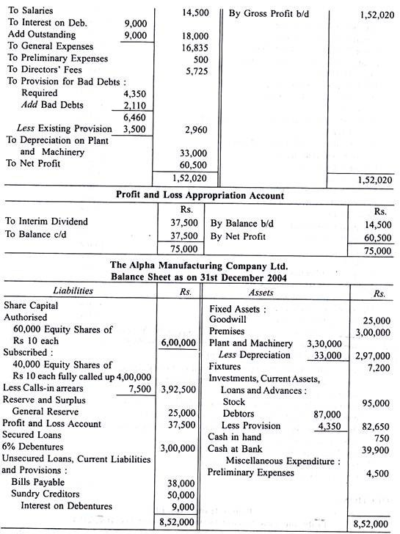](https://cdn.accountingnotes.net/wp-content/uploads/2017/01/clip_image069_thumb4_thumb.jpg)

**Problem 2:**

The authorised capital of Inter-State Distributors Ltd. is Rs 7, 50,000 consisting of 3,000 6% cumulative preference shares of Rs 100 each.

**The following is the trial balance drawn up on 31st December 2004:**

[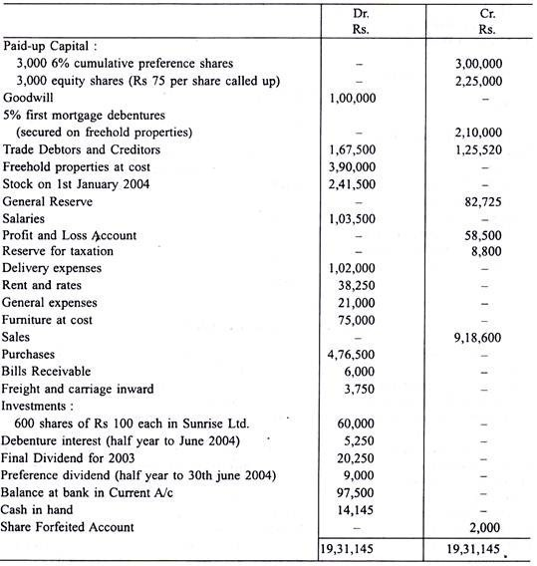](https://cdn.accountingnotes.net/wp-content/uploads/2017/01/clip_image089_thumb2_thumb_thumb.jpg)

(a) The value of stock on 31st December 2004 was Rs 2, 15,000.

(b) Depreciation on freehold properties is to be provided at 2½ A% and on furniture at 6%.

(c) The directors propose to pay the second half year’s dividend on preference shares and a 10% dividend on equity shares.

(d) Shares have been forfeited on non-payment of Rs. 35 per share. You are required to prepare final accounts of the company.

**Solution:**

[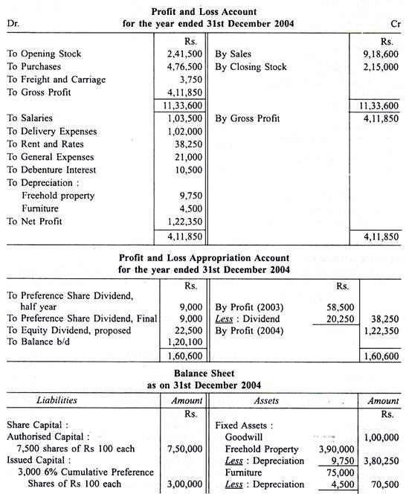](https://cdn.accountingnotes.net/wp-content/uploads/2017/01/clip_image091_thumb3_thumb6_thumb.jpg)

[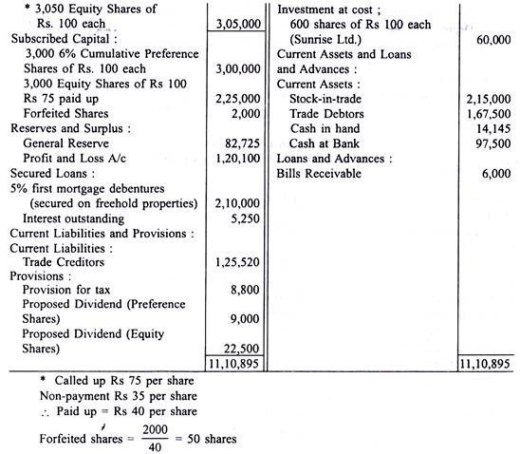](https://cdn.accountingnotes.net/wp-content/uploads/2017/01/clip_image093_thumb2_thumb_thumb.jpg)